http://puravidaapps.com/sqlite.php

Description

This extension provides access to the local SQlite database.  
Required permission:

* android.permission.READ_EXTERNAL_STORAGE,
* android.permission.WRITE_EXTERNAL_STORAGE

Probably you want to read this first: [What is SQLite](http://sqlite.org/about.html) and [what is a relational database?](http://zetcode.com/db/sqlite/introduction/)

There is a nice [SQLite Manager extension](https://code.google.com/p/sqlite-manager/) available for the Firefox Browser, which makes it easy to manage the database. See also [sqliteexpert.com](http://www.sqliteexpert.com/) for a tool to design your database.  
  
[Please see here for the SQL syntax](http://sqlite.org/lang.html).

* Each app has its own SQlite database.
* There is only one SQlite database per app.
* Even if you have multiple SQlite components, they will use the same database.
* With AI Companion, all the apps using that Companion will share the same SQlite database.
* That sharing will disappear once the apps are packaged and installed on the phone.

### During development clear the Companion app's data each time you start working on a new app.

|  |  |
| --- | --- |
| **Properties** | **Description** |
| http://puravidaapps.com/images/extensions/sqlite/ignoreHeader.JPG | Returns whether the header row should be ignored in the result of a Select statement. |
| http://puravidaapps.com/images/extensions/sqlite/setIgnoreHeader.JPG | Specifies whether the header row should be ignored in the result of a Select statement. |

|  |  |
| --- | --- |
| **Events** | **Description** |
| http://puravidaapps.com/images/extensions/sqlite/errorOccurred.PNG | Return error message (only for Import and Export methods). |

|  |  |
| --- | --- |
| **Methods** | **Description** |
| http://puravidaapps.com/images/extensions/sqlite/execute.PNG | Execute query in SQlite database.  Data is return when using a SELECT statements; otherwise, in case in case the query was successful, "done" will be returned, else an error message.  It is posssible to have commas inside table values. In this case, for SELECT queries which return more than one column, the result will be quotified by double quotes. |
| http://puravidaapps.com/images/extensions/sqlite/export.PNG | Export database. Prefix the filename with / (i.e. relative path) to store the database on the SD card. For instance /myDatabase.sqlite will store the database at /mnt/sdcard/myDatabase.sqlite. If fileName starts with file:/// you can specify a complete path to the database to export. |
| http://puravidaapps.com/images/extensions/sqlite/import.PNG | Import database. Prefix the filename with / (i.e. relative path) to look for the file on the SD card. For instance /myDatabase.sqlite will look for the file /mnt/sdcard/myDatabase.sqlite. To import a database from the assets packaged with an application (also works for the Companion) start the fileName with // (two slashes). If fileName starts with file:/// you can specify a complete path to the database to import. |

### Example Use

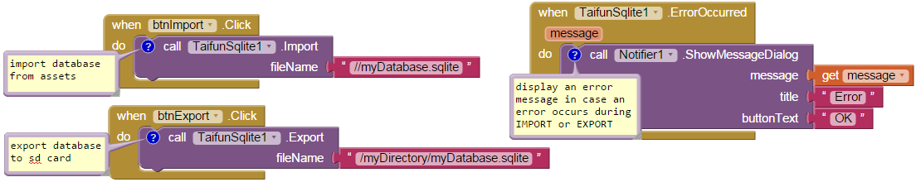  
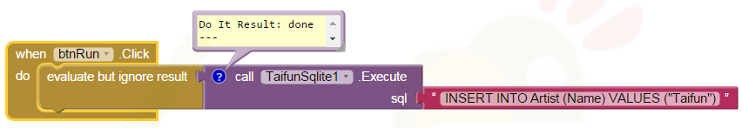

### Example App:

The example app imports the Chinook example database on first run of the app.   
Alternatively you also can import your own SQlite database, export a database and execute some SQL queries to test the functionality of the SQlite extension.

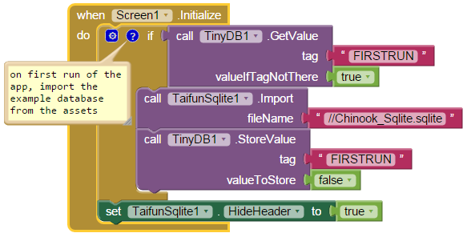

### 

### 

### 

**What about solving some queries (questions taken from** [**here (pdf)**](https://cs.uwaterloo.ca/~tozsu/courses/CS338/F13/assignments/Assignment1.pdf)**?**

* Which artists did not make any albums at all? (See my solution above in the blocks screenshot)
* Which artists did not record any tracks of the Latin genre?
* Which video track has the longest length?
* Find the names of customers who live in the same city as the top employee (The one managed by anyone).
* More tasks see [here (pdf)](https://cs.uwaterloo.ca/~tozsu/courses/CS338/F13/assignments/Assignment1.pdf)